
Dear Elon Musk & Company, AND
To Every AI Company Globally
My name is Evan, and I am delivering to you
🚨 SPECIAL OPERATIONS REPORT #9 🚨
from OPERATION $YING $YANG
@@ MAGIC EYES ONLY
0504 AUG 13 2026
SAV @EX13
SAV @EX38
SAV @EX79
1999888777666555444432333321222200190160150128100997972695949393829191817161615141312111009080706050403020100xm

@@ I MUST DELIVER A MESSAGE TO THE OFFICE OF THE RED PHONE
@@ “LISTEN,”
@@ “12.18.26 IS DOOMSDAY”
@@ “🕸️🕸️”
@@ “e.s. SPIDERMAN”

I’ve spent my entire life being told by farmers, tradesmen, and communists to shut up. I’m wrong. I don’t know what I’m talking about. I’m stupid for expecting to get a job working in tech after contributing 20+ years of my life dedicated to computers. I’m told I need to go work in the trades to earn money in this province. Alberta. The same province that has spent the past 25 years marketing itself as Silicon Valley 2.0. Does no one pay attention to politics in Alberta?
It appears that Mark Zuckerberg is the only individual among the Billionaire Elite with any business sense. The recent announcement of the Sturgeon, county Meta AI Data Center has opened the flood gates to new potential into this province. For once the marketing efforts of the provincial government to attract tech to our province have worked. Why? We have an abundance of the power and land to build all this shit. The real Silicon Valley 2.0.

It’s starting with the Meta facility and we are building BIG. Welcome to Texas North YIEEE HAW LIL BUDDY! 🤠 👽
I’m planning video game inspired amusement parks, underground hyper speed trains, AI powered skateparks, alien themed coffee shops, new game studios and LGBT gay bars. And none of you seem the least bit interested in talking to me about my future vision for the province of Alberta.

I find it remarkable that Musk has been terminally blind to the potentials of Canada. You’d think given the provincial budget for the AHS healthcare system, and that the AHS is the number one employer of tech workers in this province Musk’s Neuralink company would want to collaborate with our doctors and nurses to upgrade our failing systems. It shouldn’t take 20 minutes for the hospital to send a digital document 50 yards away to another room. Yet that’s the time I measured when I was last there. Given that Musk’s mother lives in this country I think he would find it prurient to understand the state of our economy.

25 years of promising to build tech while doing nothing to actually bring the innovators in was a mistake. Danielle Smith has finally connected the pieces bing bang boom ! Natural gas becomes electricity. Electricity becomes computing power. Compute becomes intelligence and that is how we transform Alberta into the trillion dollar powerhouse of the future it was always promising to be. Mark understands the potential of this province why can’t Musk?
https://youtu.be/-lfY6RPElqc
Perhaps Elon would be interested in learning about our filming industry up here given his mother is an actress/model as I understand. I just went to see the new Spiderman movie at a theater that’s over 100 years old with the vintage seats kept in the back for historic value while the front has modern comfortable seats to sit. In the credits of the film Canada, Quebec, and the province of BC were listed. For a Hollywood produced Marvel movie based in New York City. Numerous kids at the theater screamed out when they recognized me! I’m THE SPIDERMAN anywhere I live!
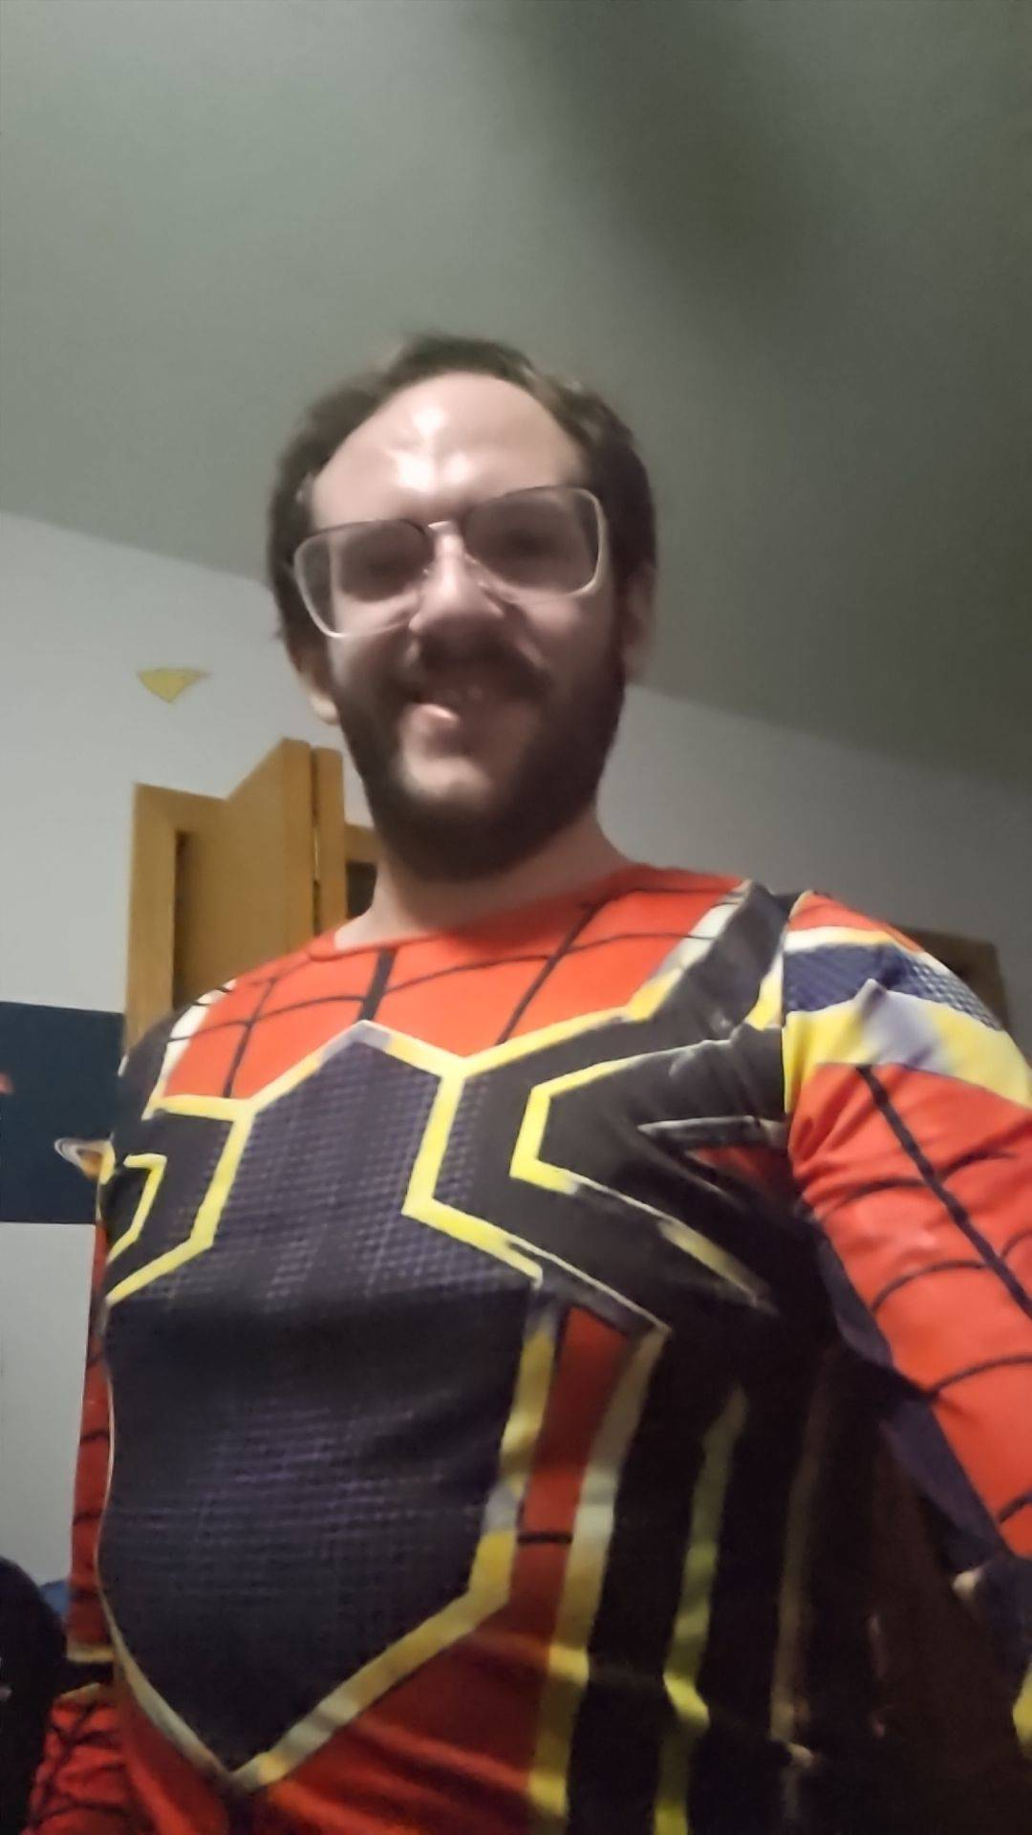
“BRING ME PICTURES OF SPIDERMAN!” 😂 😂

You know what makes Spiderman a Villante? His willingness to break the rules and do things he knows need to get done without asking for permission first.
You know what makes Spiderman a Hero? His willingness to break the rules and do things he knows need to get done without asking for permission first.

You tell me one other person on this planet who thought of using job application portals as a means of transmitting secured information. IM THE ONLY ONE! Perhaps the AI companies promising to safegaurd their technology from litterally killing everyone on the planet would like to hear about the past 2 years of research done on behalf of the RCAF.
They can’t claim they didn’t know. I have a guy on the inside. If he failed to communicate the information regarding OPERATION YING YANG, that’s not my problem. I am Spiderman and I have been fighting the Chinese mind virus none of you were even aware of.

- SOUND
MUSIC
- FREQUENCY
- VIBRATION
are the control leavers of the universe
None of you stopped to ask the question whether the number one MUSIC app being based in China has anything to do with the ways our lives in the west have changed. If China was using humans to engineer mind control techniques through sound apps in the past, then God 1M1M1 help us all when they apply the AI research tools they build to perfect it. Welcome to World War 3!@@
@@
0+0=0
2+2=5
3+3=WW3
SAV @EX03

In the movie Spiderman Brand New Day; Spiderman routinely stays in communication with the police chief for the city about his wearabouts and whats he’s doing. Given that you ALL HAVE MY NUMBER there should be no excuse to ignore these messages. If yall want to use the AI to do something more interestersting than automate email flows give me a call when you are ready to discuss time travel and mercury theorium reactors!
(403) 994-2826
TELL THE OFFICE OF THE RED PHONE TO CALL ME ☎️ ☎️
TELEPHONE OPERATOR @#EX38

TELEPHONE OPERATOR
PHONED YOU UP AN HOUR LATER
TELL ME IS IT LOVE
LAUGHING BECAUSE
I HEARD IT BEGIN
AHH HA HHA HA HA
YOU!
SAV @EXYOU
$YOU

IS IT BECAUSE YOU’RE MINE
TELEPHONE OPERATOR
YOU’RE MY ORAL SIMULATOR
TELL ME IS IT LOVE
LAUGHING BECAUSE
I AM E.S. SPIDERMAN, and I approve this message 🕸️🕸️
SAV @EX79
https://www.instagram.com/p/CvTX-g7A88l/

<<>>
👽 👽
TRIST MAGICTIS
🕸️ s.

